Business activities

Sales, Marketing, customer services, Services activity, goal management

Administration

To customize your app (Working hours, holidays,…) From advanced setting

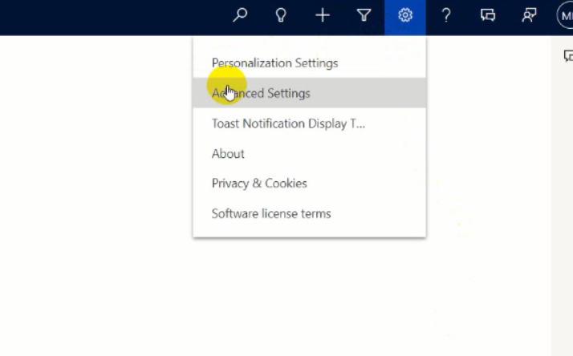

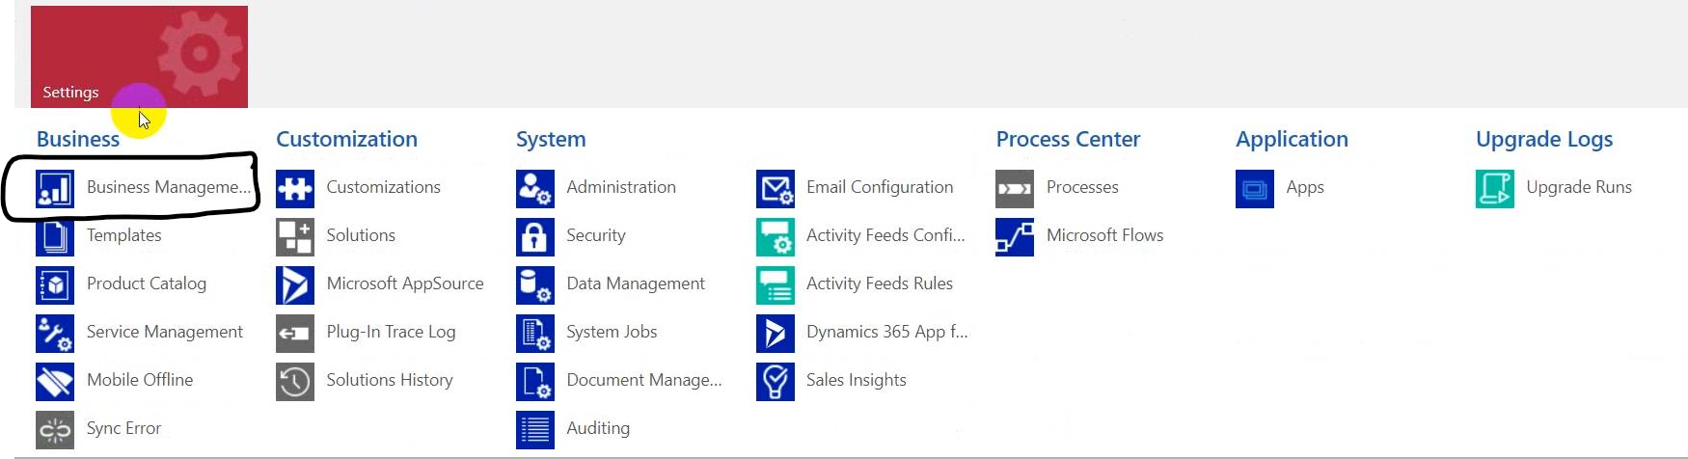

Now will switch into Business managment

* Goal management: Amount, Count (to set how you can measure goals).
* Facilities/Equipment: Facilities and Equipment that will use in service schedule (Like car and delivery man in last lecture example).
* Resource groups: to add more than one equipment and facility on it to deal with them as a group.
* Services: Service scheduling (like delivery services in last lecture example).
* Subject: To manage subject hierarchy for organization, to set hierarchy of subjects (Like set subject name for cases).
* Currency: To manage currency or to change default currency.
* Sites: to manage sites or to add area (like Nasr city in last lecture example)
* Sale Territories: to divide sales team into territories and add manager in this territory.
* Queues: To manage queue of services to Automate something after creating a record.
* Business Closures: To manage holidays or to set time on it business will be closed.
* Fiscal Year setting: To set date details (Quarter, Year, Month...).
* Automatic record creation and update rules: To automate record creation or updating (like if you received an E-mail with specific subject to create a case or update a thing).
* Rollup Queries: To set an automated query in a group of related data (like to create rollup query to calculate summation of revenue from specific field so we can say to track field in entity and cumulative the summation of it).
* 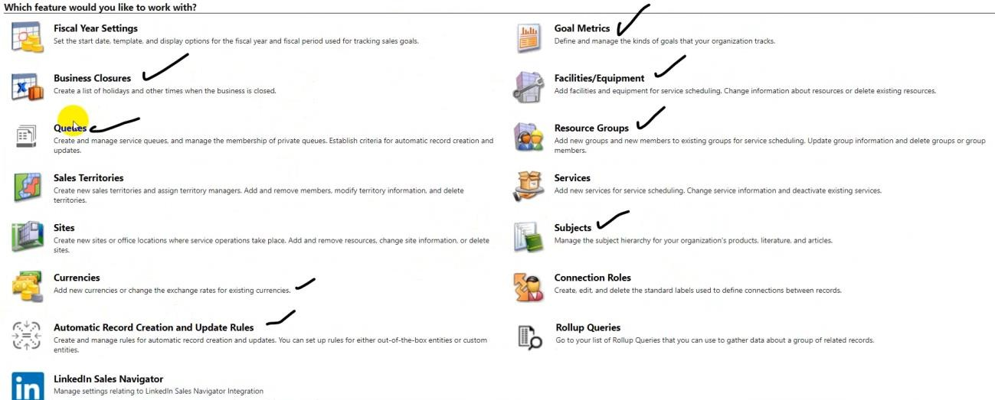Connect roles: To set relation between two recodes.
* Now will switch into Templates

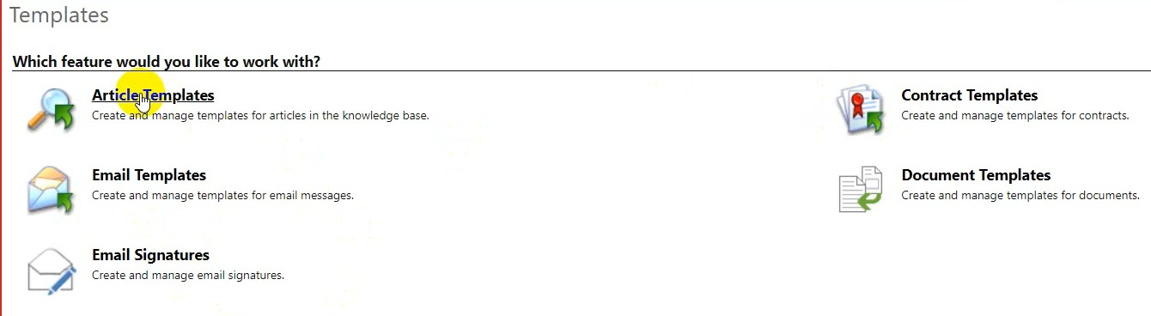

* Contact Template: Is deprecated now.
* Article Template: To create or update template of article.
* Email Template: To create or customize your email template. (شوية تمبلت جاهزة)
* Email Signatures: To create email signature.
* Document templates: to create or manage documents.

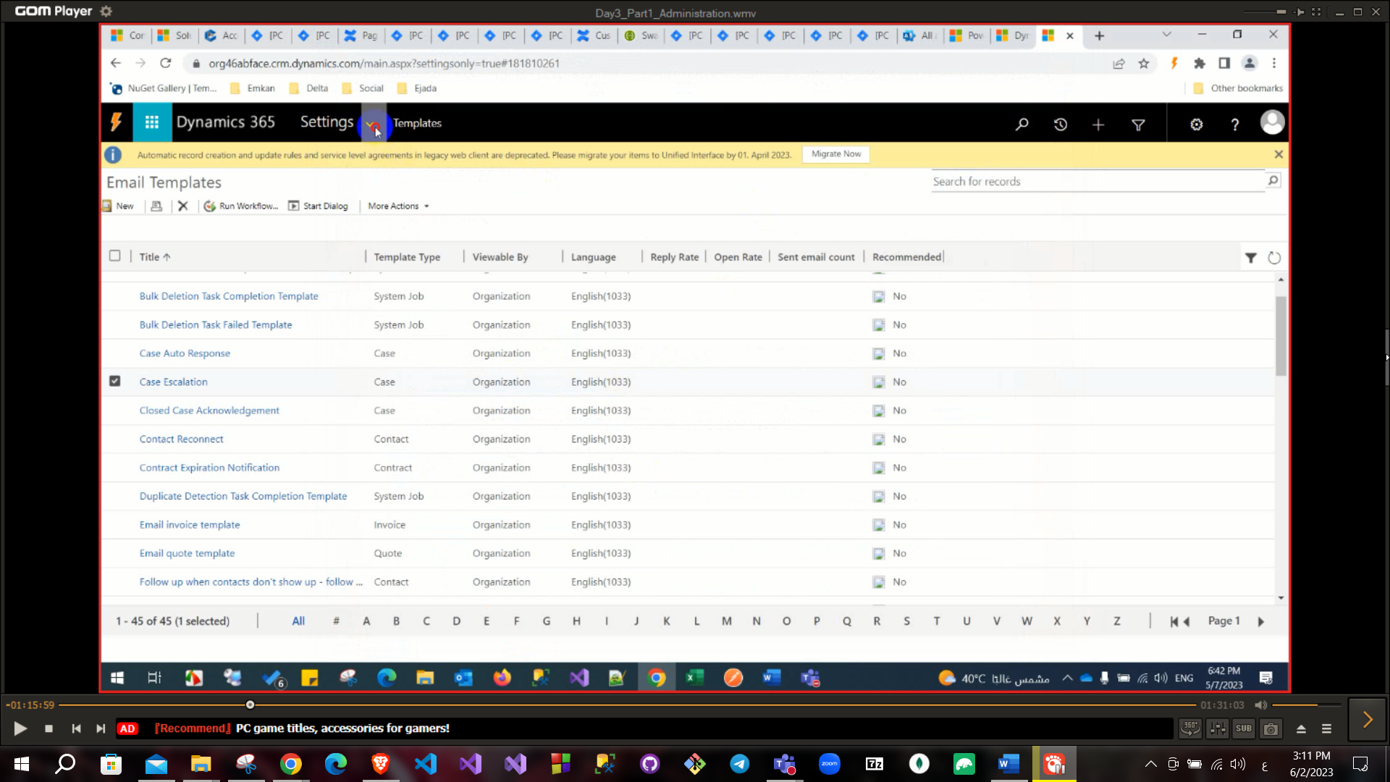

Now will switch into Product Catalog

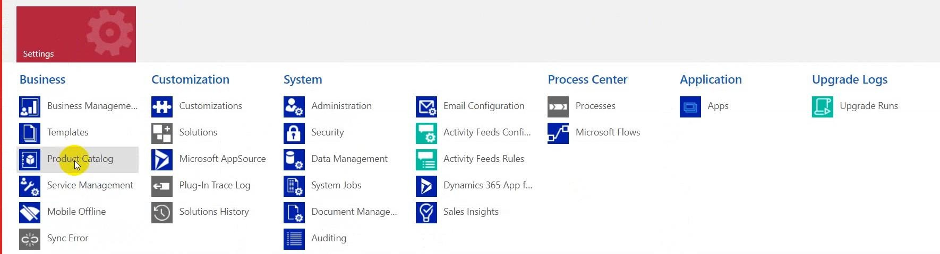

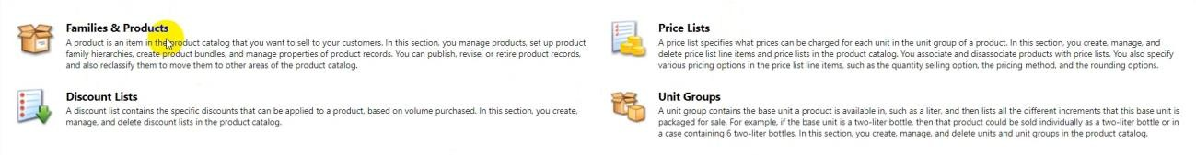

* Families & Products: (like laptop is a family and laptop dell is a product in this family).
* Price list: (like case if we have a product with different currency price).
* Discount List: (percentage or amount) and set a condition to apply this discount when it success (Like when you buy 4 products apply discount).
* Unit group: (Like a laptop box contain charger and laptop)

Now will switch into Service management

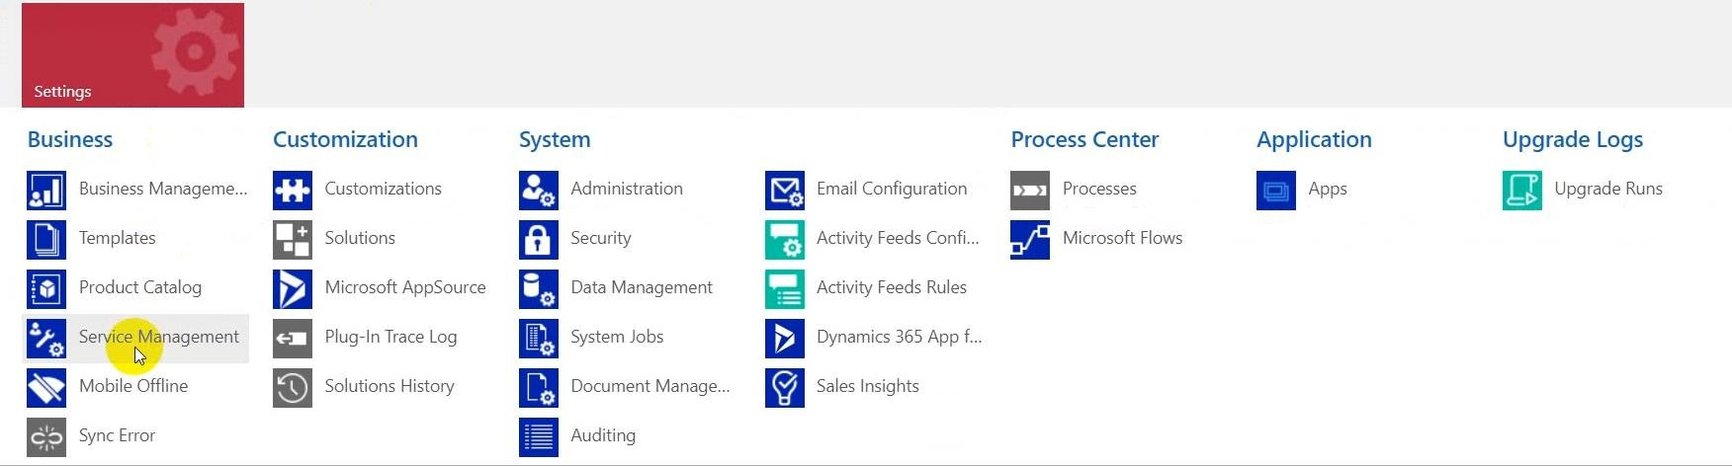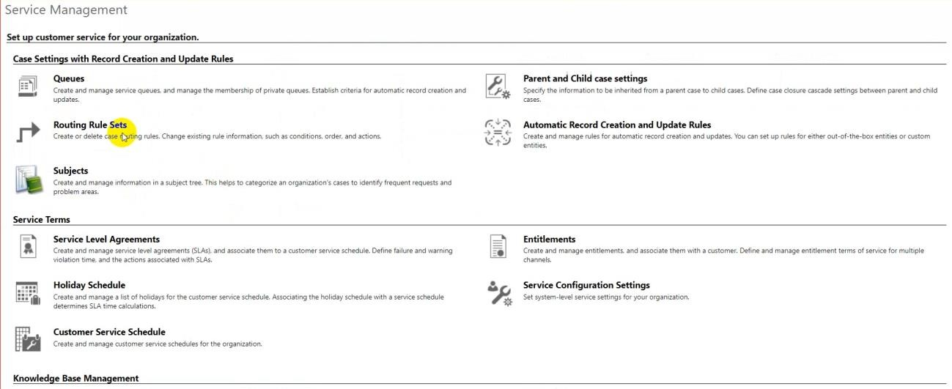

* Routing rules sets: To route tasks to queue and assign this case to someone (by click on save and route).

When select a queue item from view you can button on pick to assign this task to you.

* Parent and child case settings: to specify information to be cascaded from parent to child.

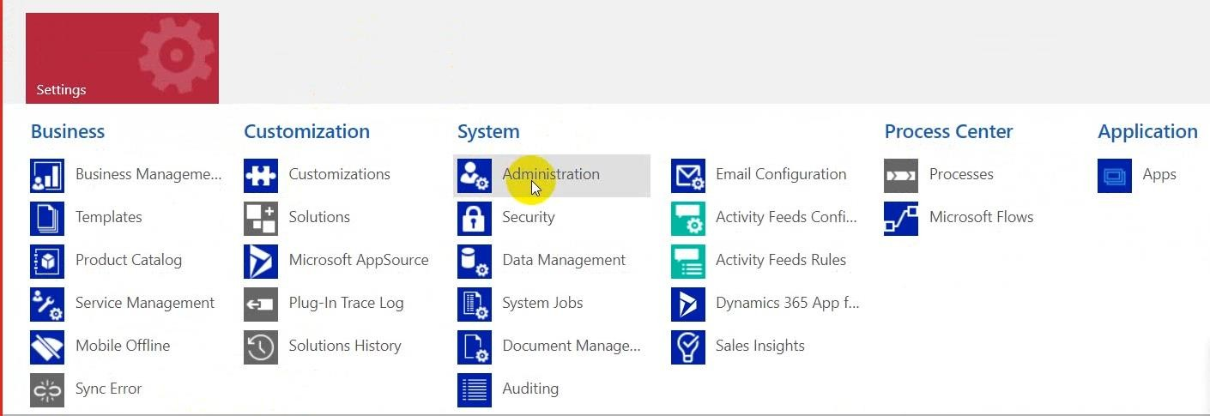

Administration

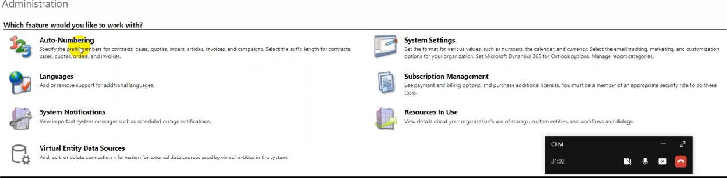

* Auto-Numbering: To set auto numbering on entity number when it created like cases, contacts or when you add custom entity you can add pattern of auto numbering (with prefix, Number, Suffix length).
* Language: To set more than one language, after download language you will see this language in settings → Options
* System notification: to set a notification and appear this when anyone open system (Like deploy time).
* Virtual Entity data sources: to retrieve data from another system and do not save this data on my system (Real-time and on the fly) will use in development (create data source and data provider) and connect on data source and retrieve your data from another external integrated system but it

separated into two types **retrieve and retrieve multiple**, but in this type works as read only cannot modify this data.  
(لو عايز اجيب ايست بالفواتير من داتا سورس تانية واعرضها في جريد عند يورز معين ده كده retrieve multiple)

(retrieve-> لو عايز اجيب فاتورة منهم دي كده )

* System setting: it has some settings (general, Format, Auditing -> to watch if someone edits in record for example as I am logging any changes in entities, Email, Sales….)

Auditing: to log who edit on table, or log anything

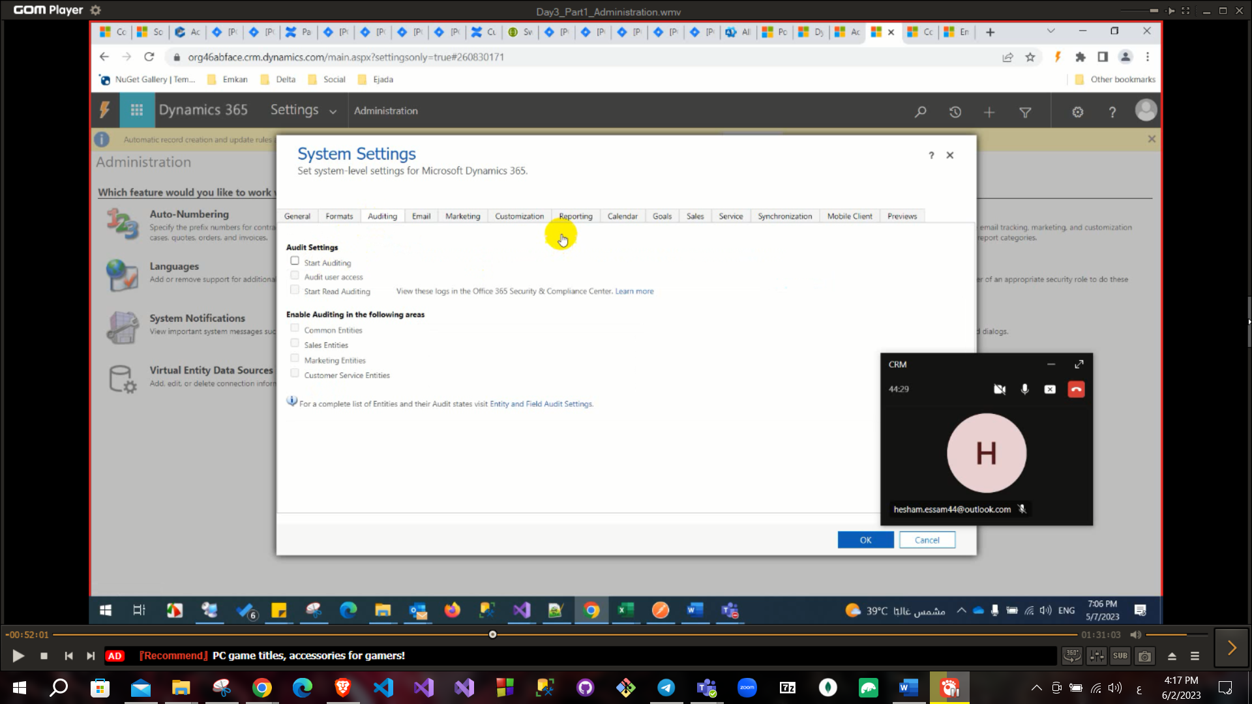

.

This tab has more settings so to need to investigate it.

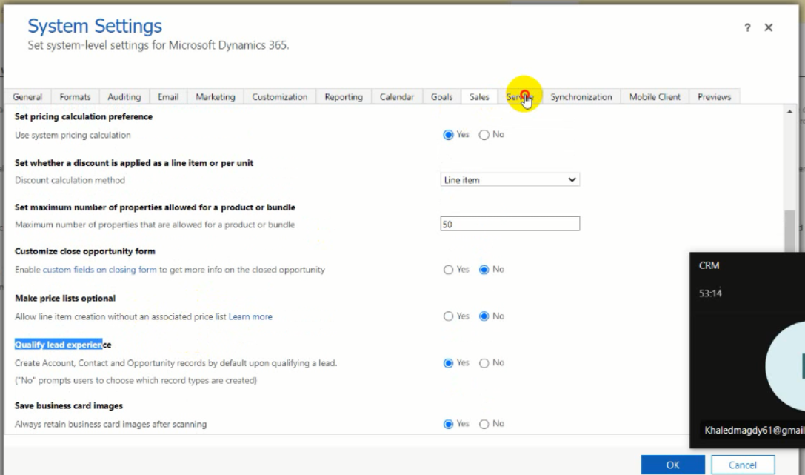

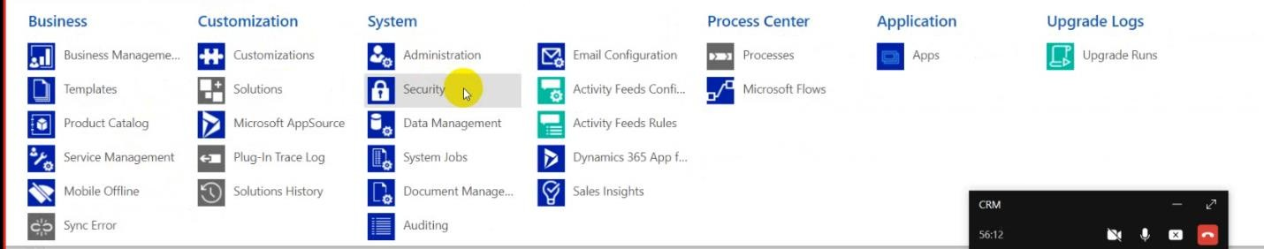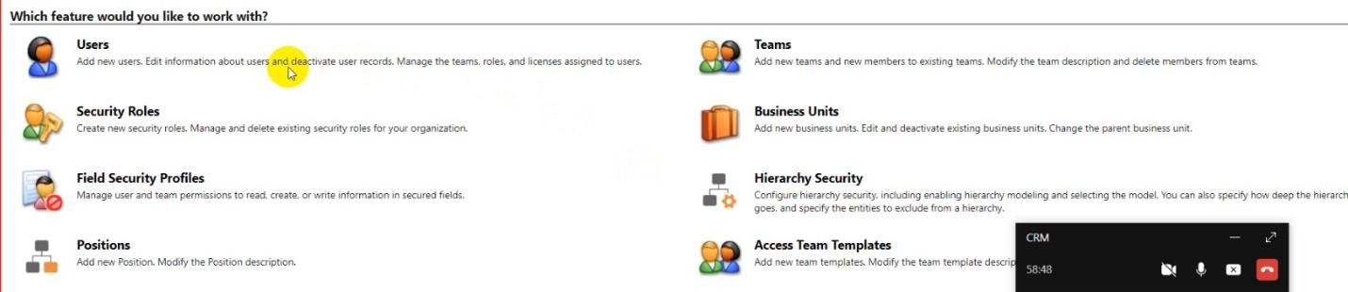Security tab is very important

* User: a person has access on CRM (if you connect on active directory you need to add this user in this active directory).

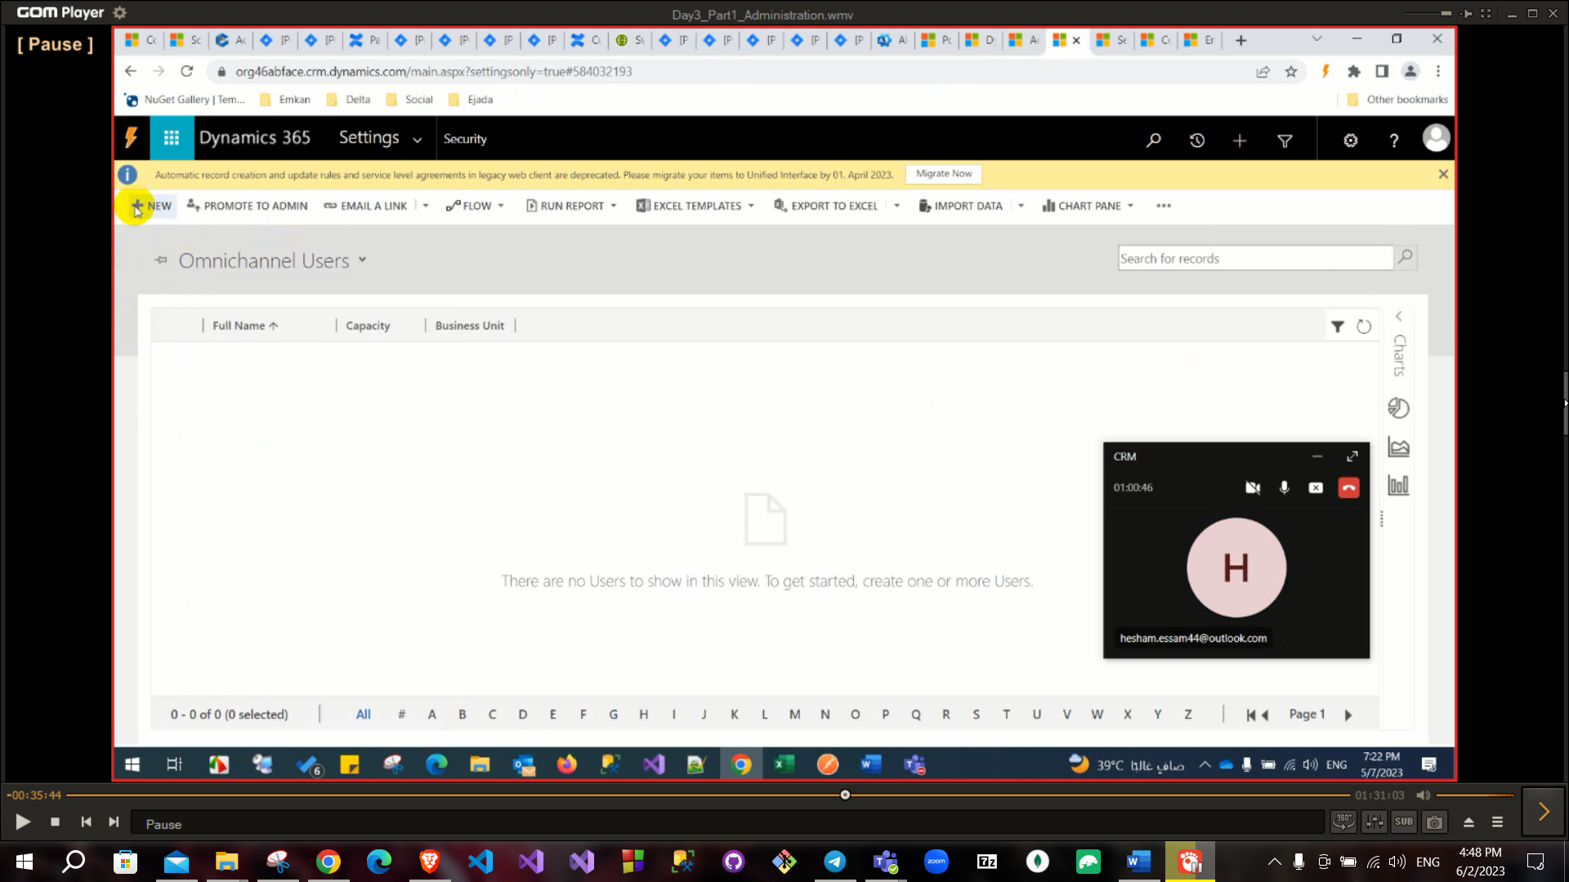

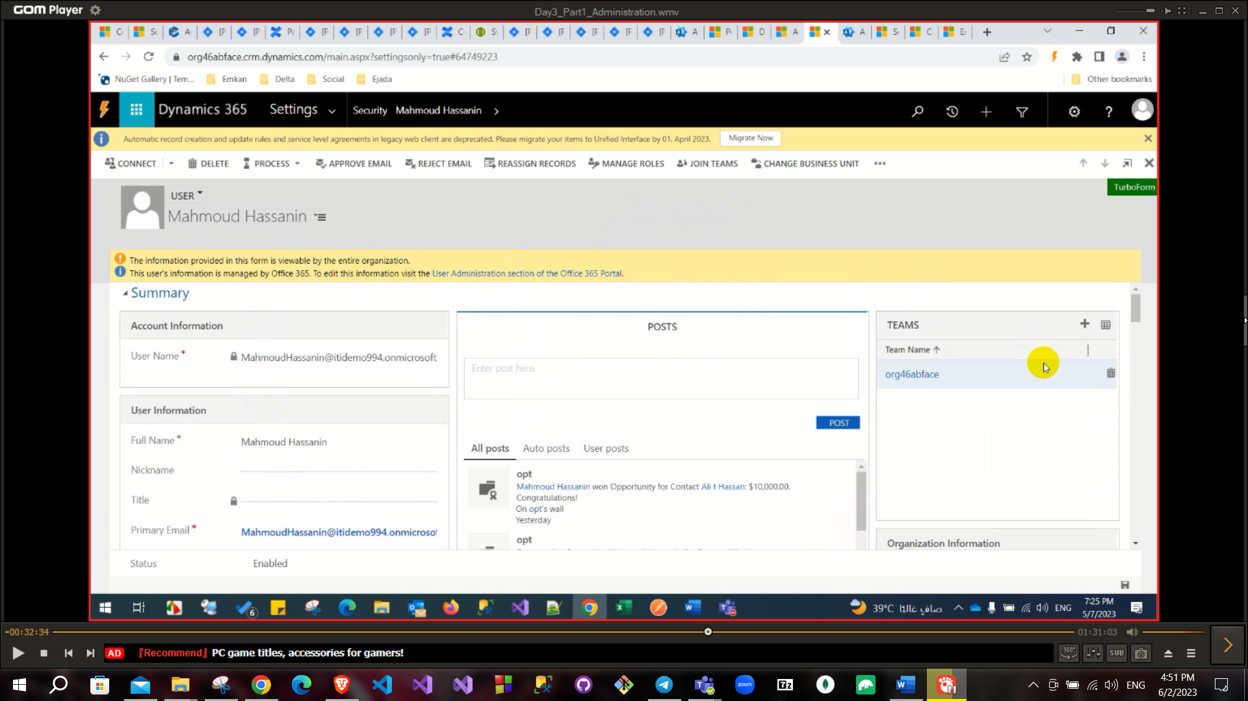

And from manage role in the ribbon buttons I can assign security role

* Security role: a salesperson (set some privileges and add them into security role and set this role to this User).

**\*\*There is a default admin always found called “system”**

* Teams or owner team: when you create a team and set some users on this team, they can see records that created from one of them and edit on these records.
* Business units: As department

Ahmed and Mohamed are users and together they are a team and they are part of

SD business unit and sd business unit is part of ITI business unit.

* Security Role

**You can assign a role on specific business unit but it not recommended.

*inside the Security Roles there are many security roles and If I opened

One of the roles it has many tabs like details and core records,….. and inside

The core records tab there are the entities and I can choose the permissions

This role can apply on this entity.

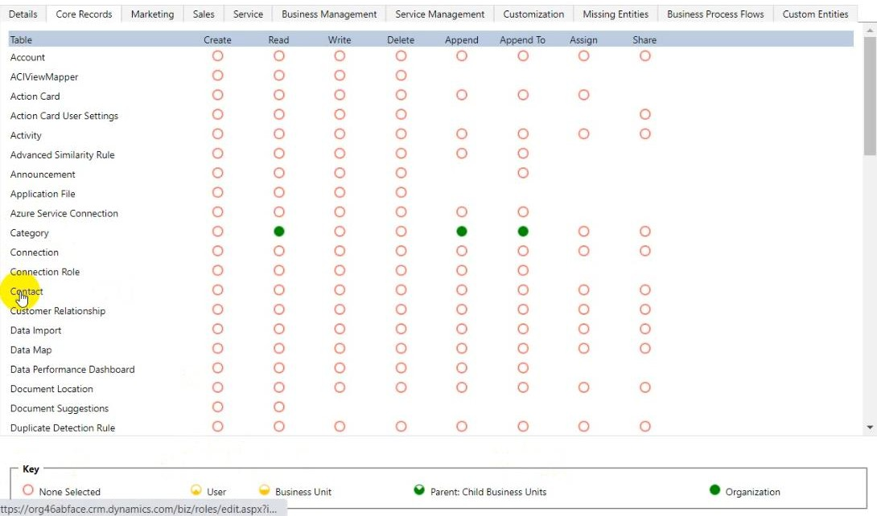

On sales there are (Leads, Opportunities…) Core Records (Contact, Account…)

# Keys access is very important:

# 

None selected: has no access.

User: has access for items that you are owner of it or my team. Business Unit: has access for item of your business unit only.

Parent child business units: has access for child business unit of my parent business unit (if we have a hierarchy ITI as a parent and PD – SWA as children in this case PD can access SWA business unit.

ITI

PD

SWA

Organization: has access for all records.

**Access levels is very important** (Create - Read – write - Delete - Append

- Append on - Share)

Append: To append lookup on my record.

Append to: To have privilege of adding this lookup on my record.

**(Like lookup the account name in the contact form, the user must have a security role with append on the entity contact and append to the entity account)**

Assign: Assign this record to someone.

Share: Share this record with another one (when this person has no access to it and set privileges also to him).

**Example to demonstrate append and append to: if you add access to someone to add account lookup to contact record so you need to add: **Append to** privilege to Account entity, also need read privilege.

**Append** Privilege to Contact entity, also need Create privilege

Let’s continue what you can find on the security tab in advanced settings:

Field Security: to secure a field (like if you have a password field in entity so you can set a field security on it so only accessed users can see this field).

Access team templates: to add privilege to users that not assigned in one team as if they are in one team.

**Difference between **access team templates** and **owner team** is very important.

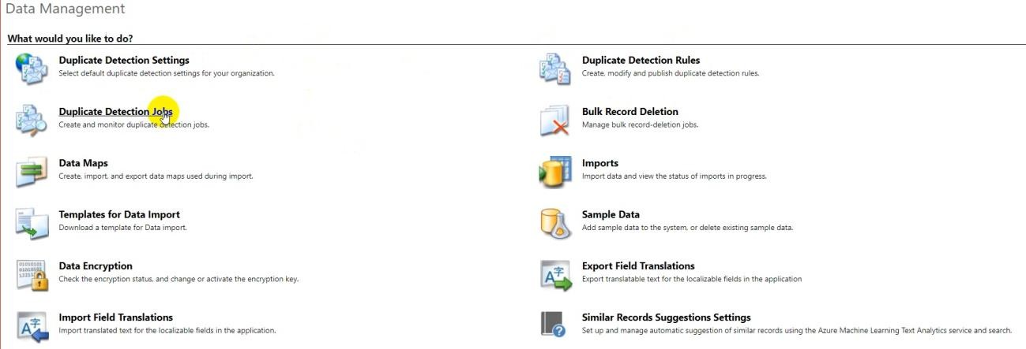Now we will switch to Data management

Duplicate detection rules: if you want to set a rule to detect duplication case (For example if you want to do not create two casehave the same subject).

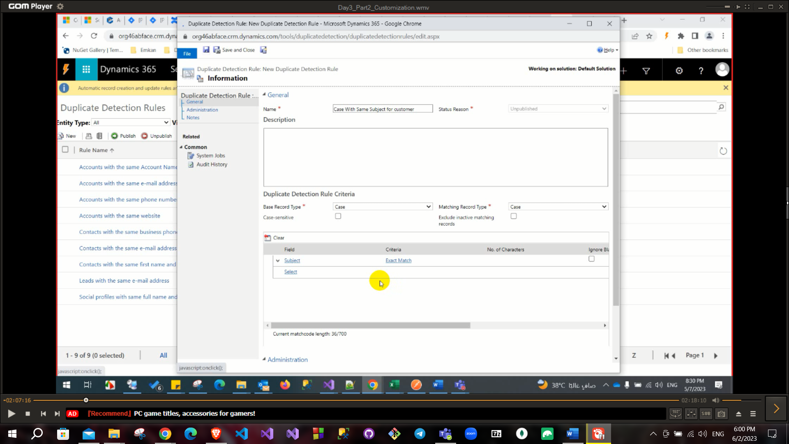

Import: to import data from external source but .CSV extension is must also you need to map this file to entity (for example to load leads records from external file note to set first row as header in this file with field name to detect mapping automatically), also you can save this mapping and use it later.

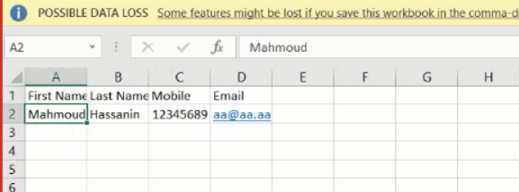

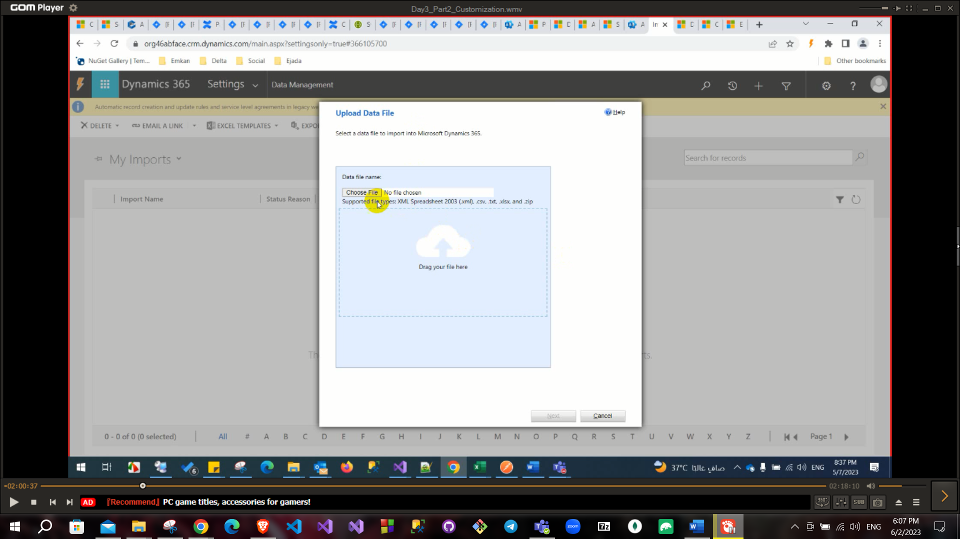

Choose the file and the mapping and **the entity** click submit.

Now if you go to lead which I chose as the entity there will be the imported record.

After importing you can double click on it to route to adding records from imports.

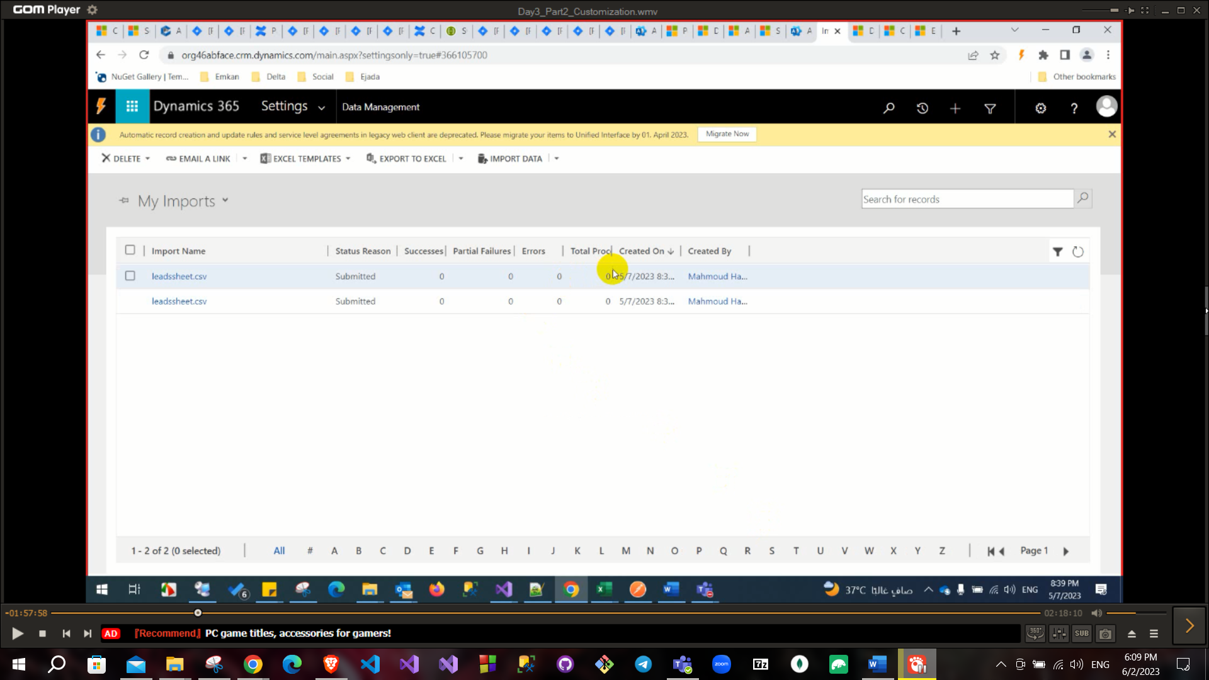

Data maps: To set pre-defined mapping pattern to use during import.

Data-Encryption: it has an encryption key of your organization so you can check it or edit it.

# Customization:

# From Advanced settings

Apps → Create new app (first step in customization) like sales, services.

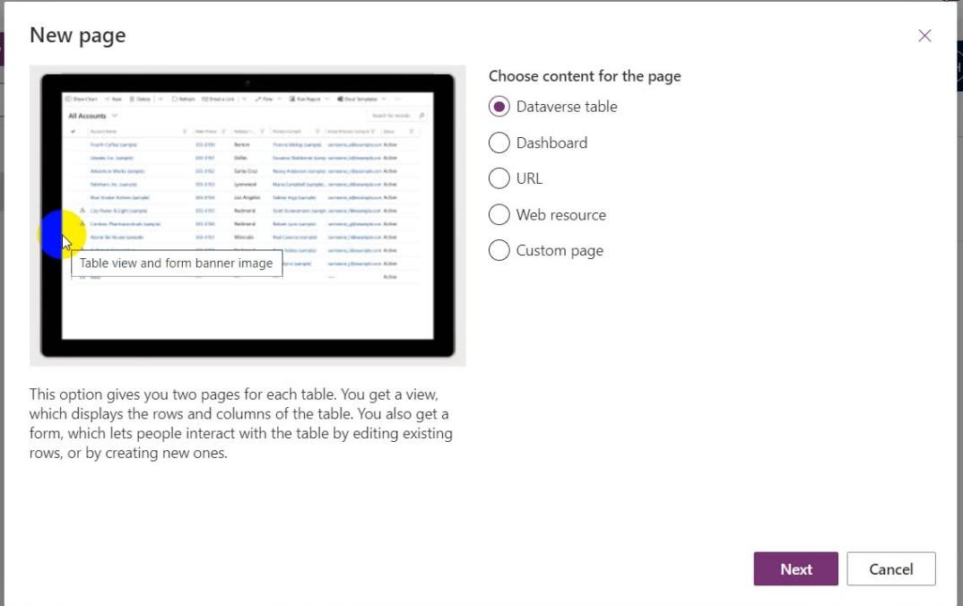If you click on new page button:

**Then you can choose the contact or the account or any out f the box entity**

**to be on your app.**

Dataverse table: to redirect it for entity.

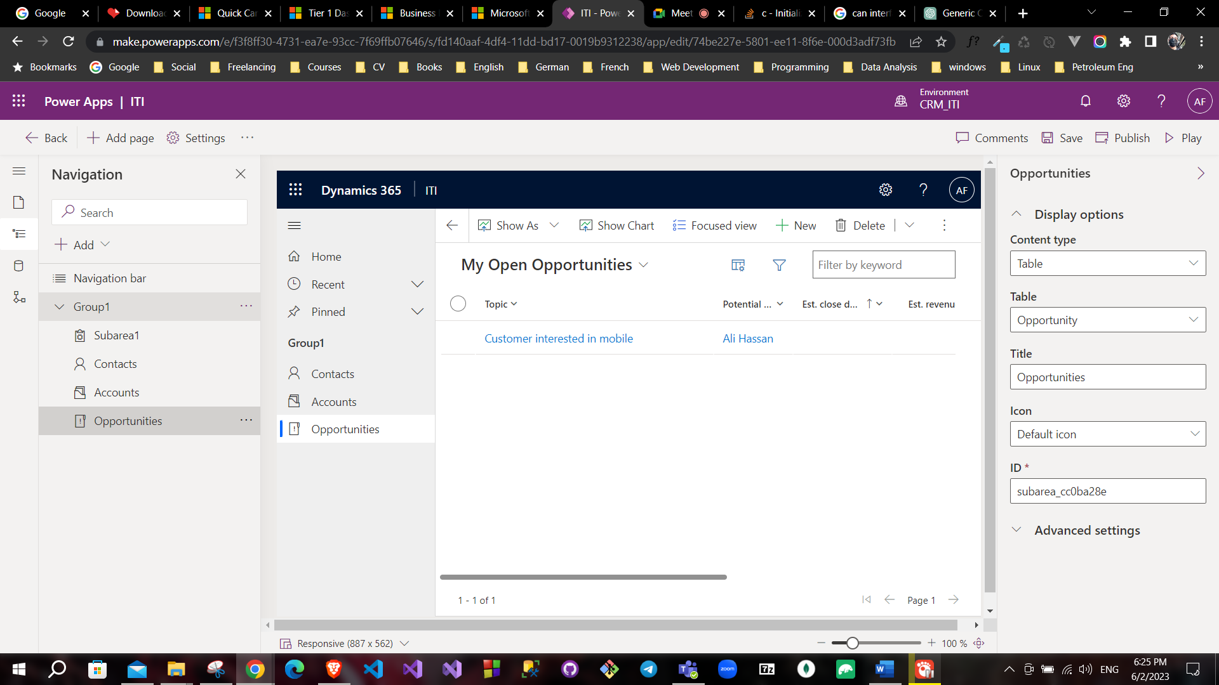

URL: to redirect to URL.

**You can set these entities into groups (like lead and opportunity put into one group).

**You can find Group on the left.**

**Also, you can customize your view (add or delete from image 2)

**Also, you can add multiple areas by enable it (like sales, services…).

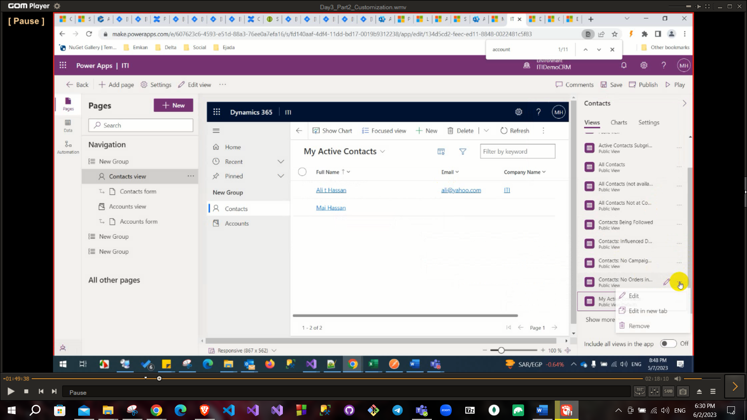

You can find the bar on the right to customize views.

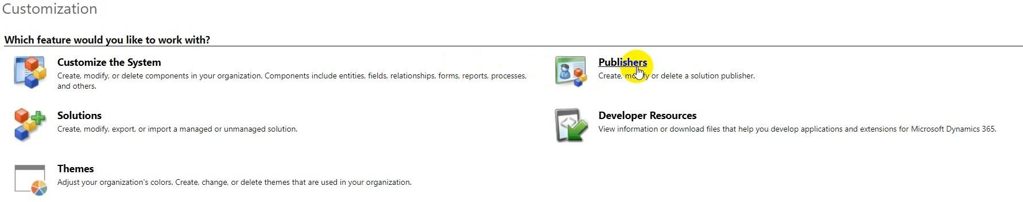From Customization tab

Theme: To modify on theme or create new one to modify colors and design and publish.

Developer Resources:

Organization services (end-point of C# code) -> SOAP,

Instance Web API (end-point of JS) -> REST

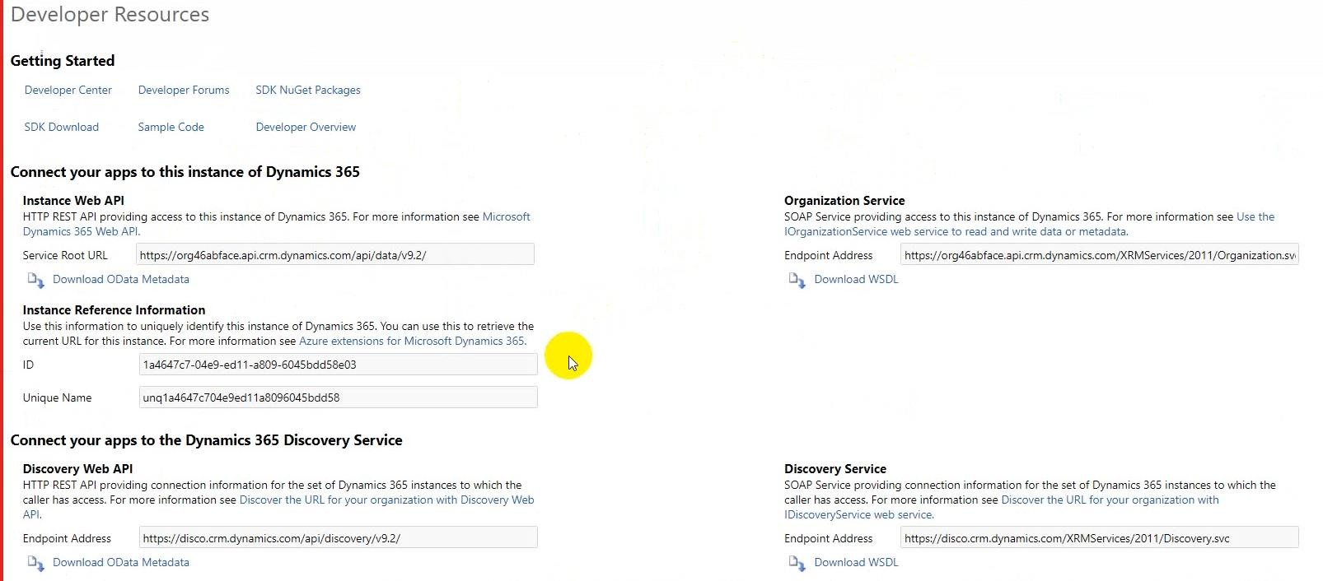

Customize the System:

to add or edit or delete (entity or field or form…).

**Relationships in CRM are (1: many, many:1, many: many).

**Business rules: to set a specific rule (like to set condition to if a field is empty then another field will be hidden).

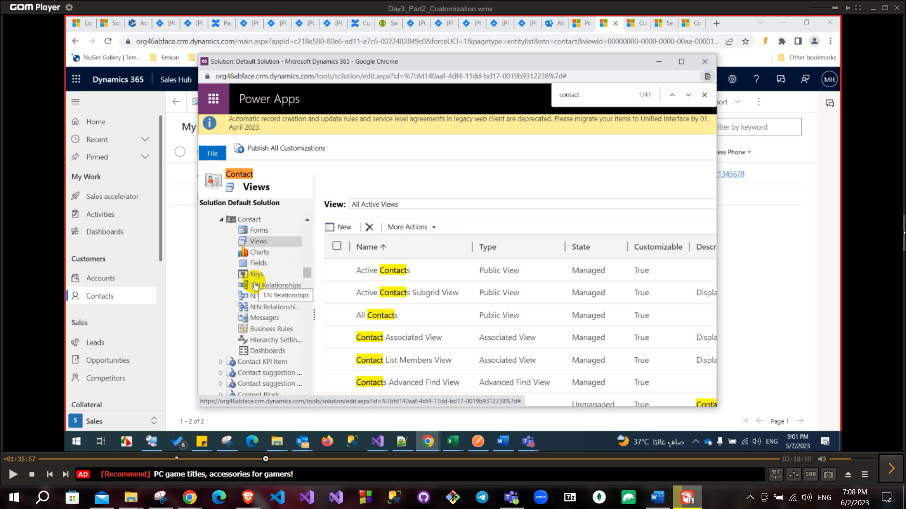

Publisher: to create publisher that will responded for a solution (for example to track what is the new entities that are created so it will have a prefix of this publisher).

Any entity will start with the prefix

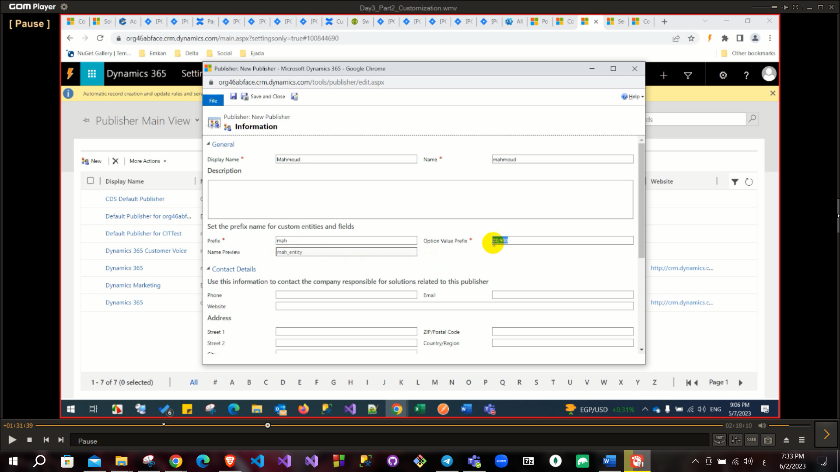

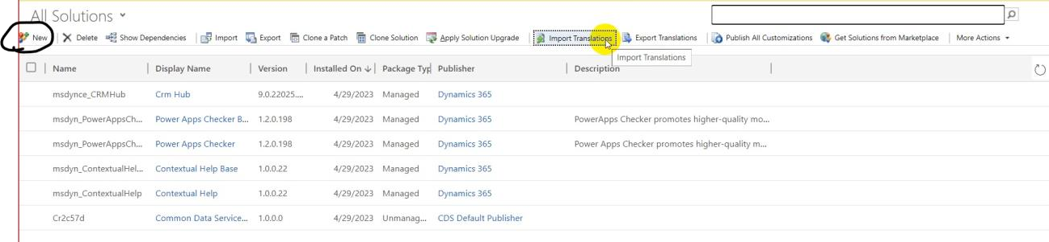Solution: To add entities or add anything on it like schema in database and you identify the publisher name

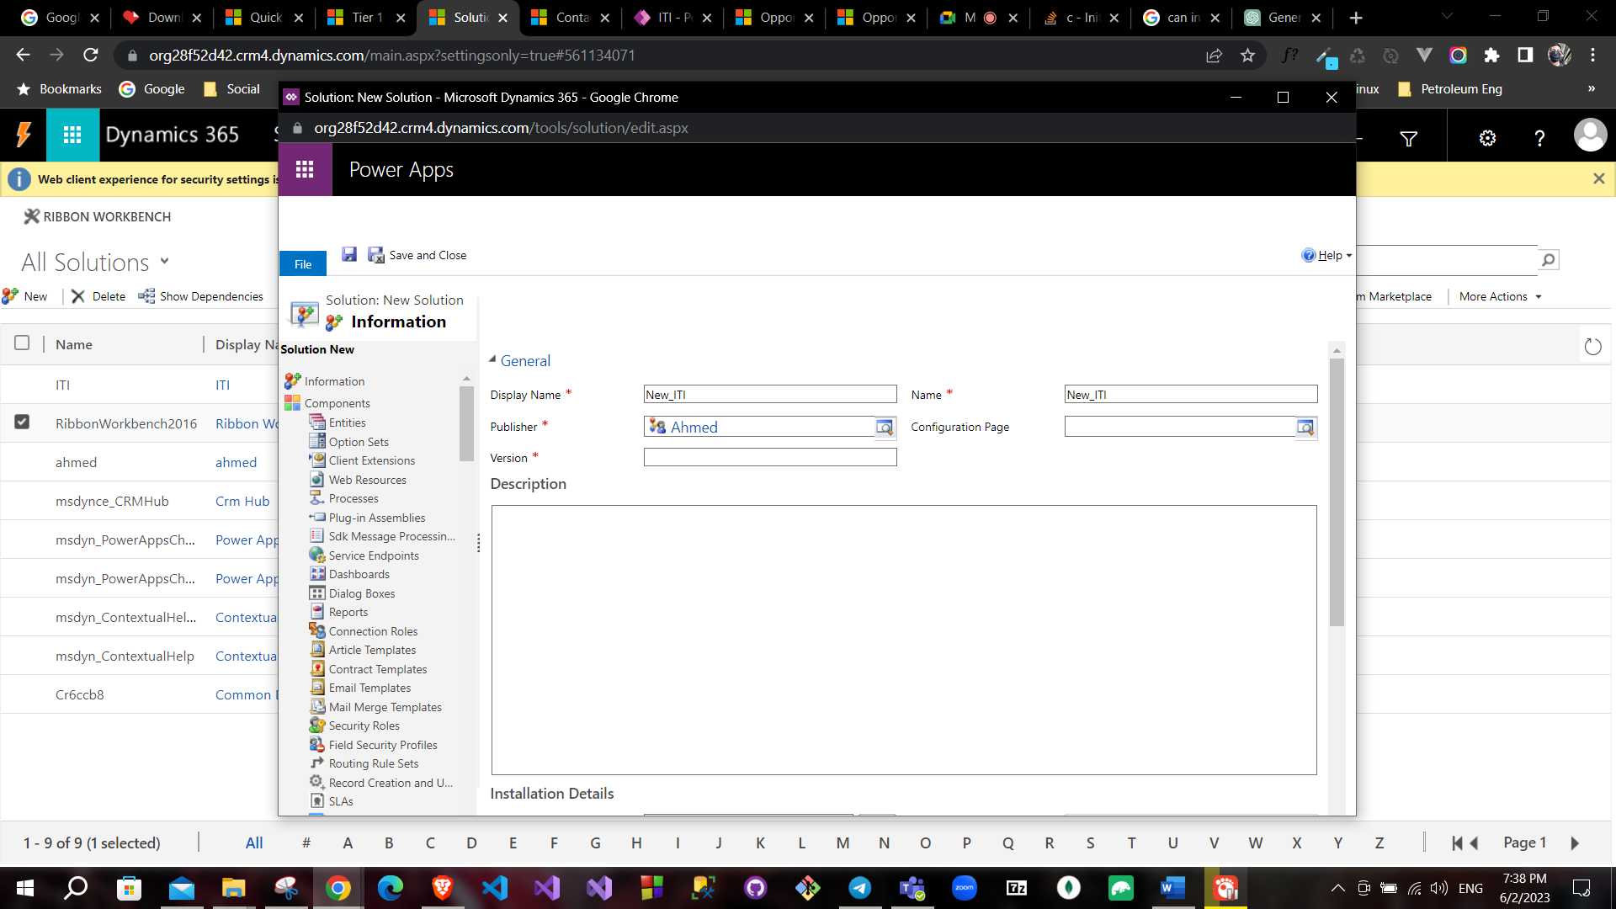

After creating a solution and button save you can create new entities on it.

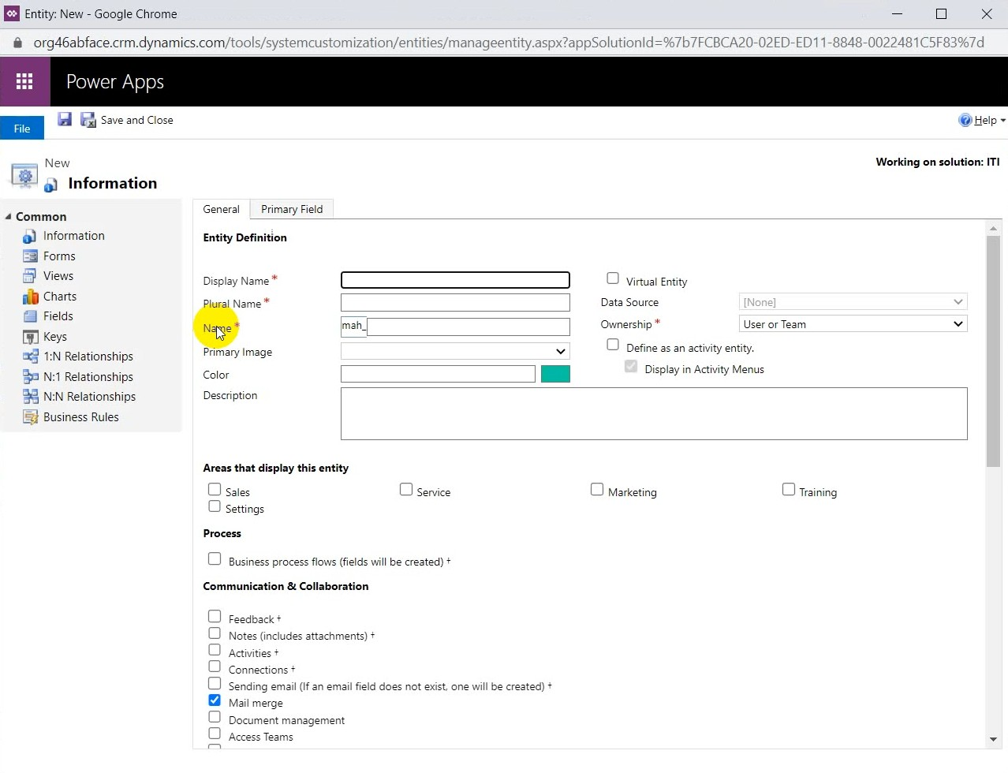

Business process flows (like sales process: create opportunity after qualify lead).

Ownership is you select organization you can set full privileges (Organization) or none selected only but user or team you can set all privileges

# All entity has primary field and this is different with primary key that also automatic created to map relationship in database.

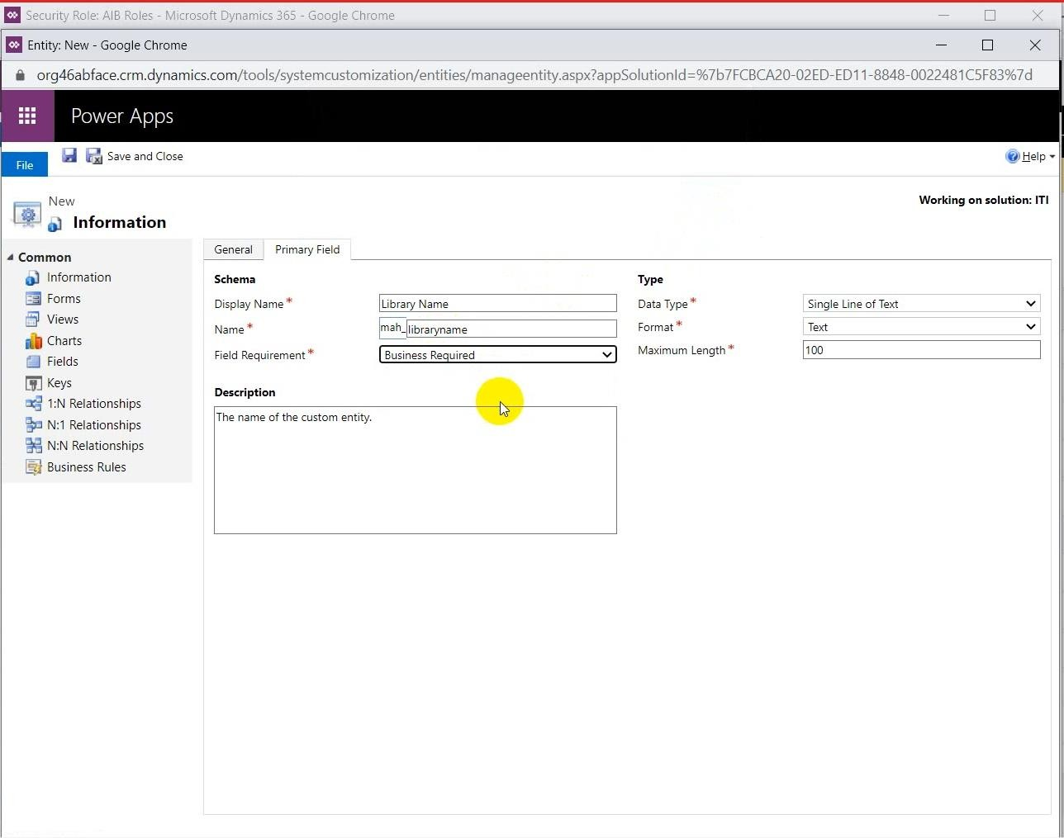

You can update icon of this entity.

All entity created has some fields (like modified by, created on, Created by, State code, status code…).

State code is active or Inactive.

Status code is a sub-code under state code.

Create new field:

Data types are important.

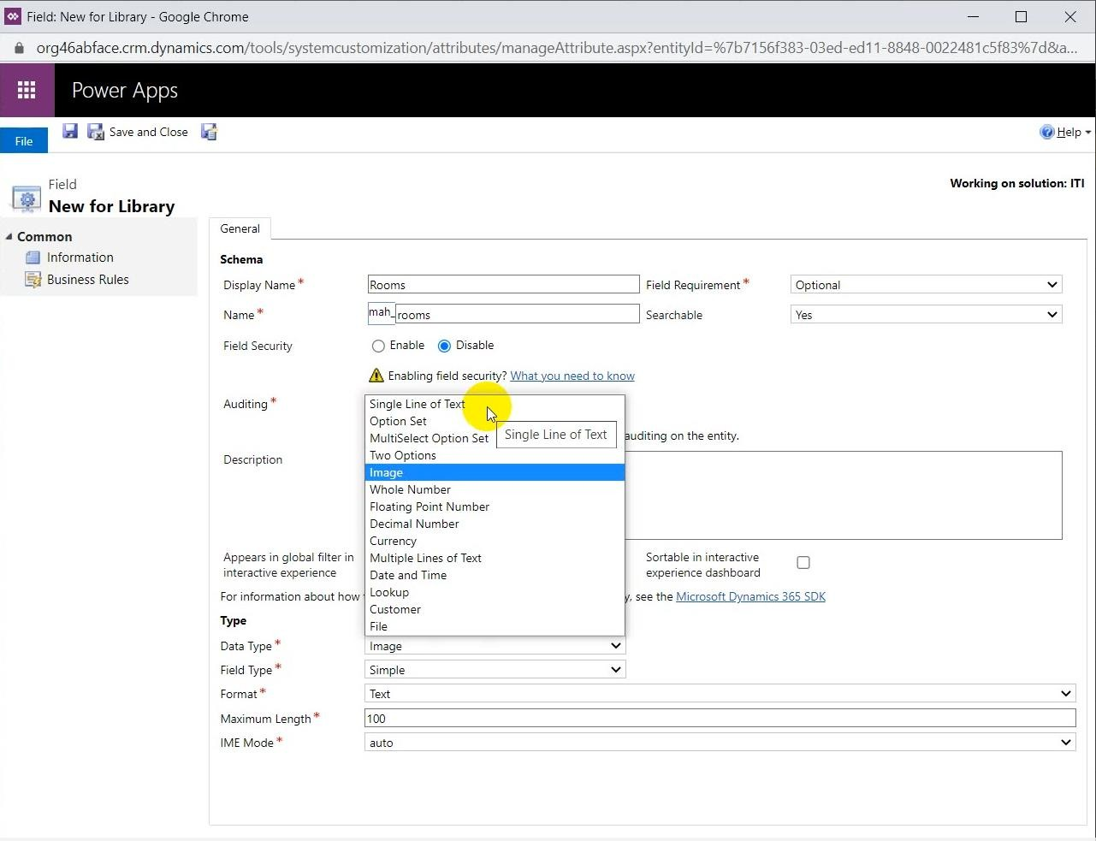

You can choose lookup and make it to add the user

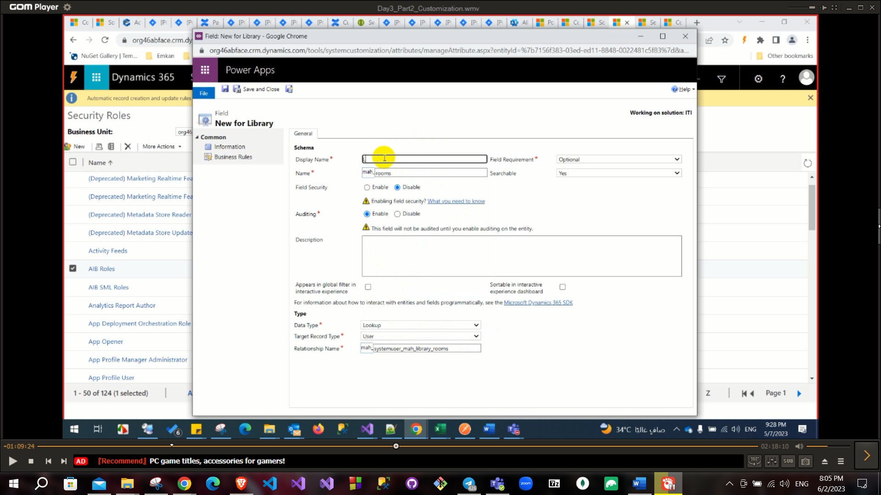

After adding fields, you need to customize them in forms

There are three default types of forms (Card, Main, Quick view) You can customize this form as you can:

Add field or section or any formatting you want to edit.

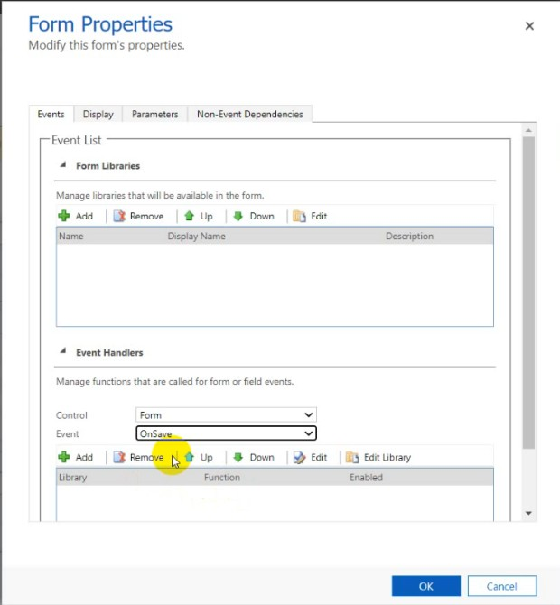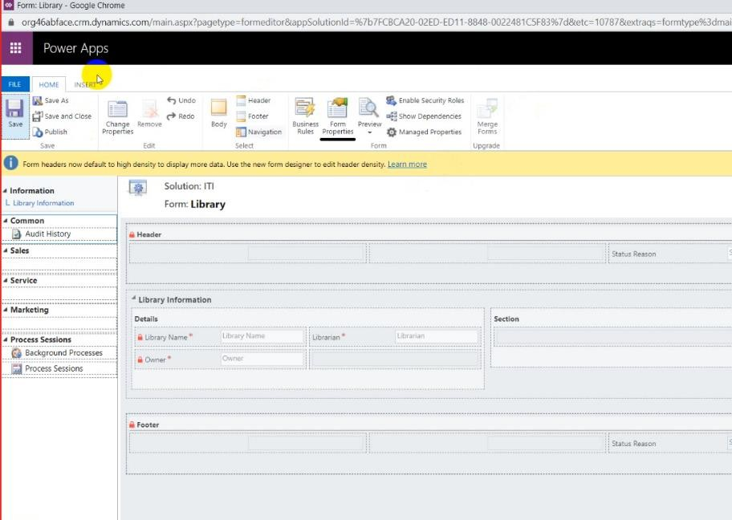

In form properties you can customize events on load or on creating using JS in next lectures.

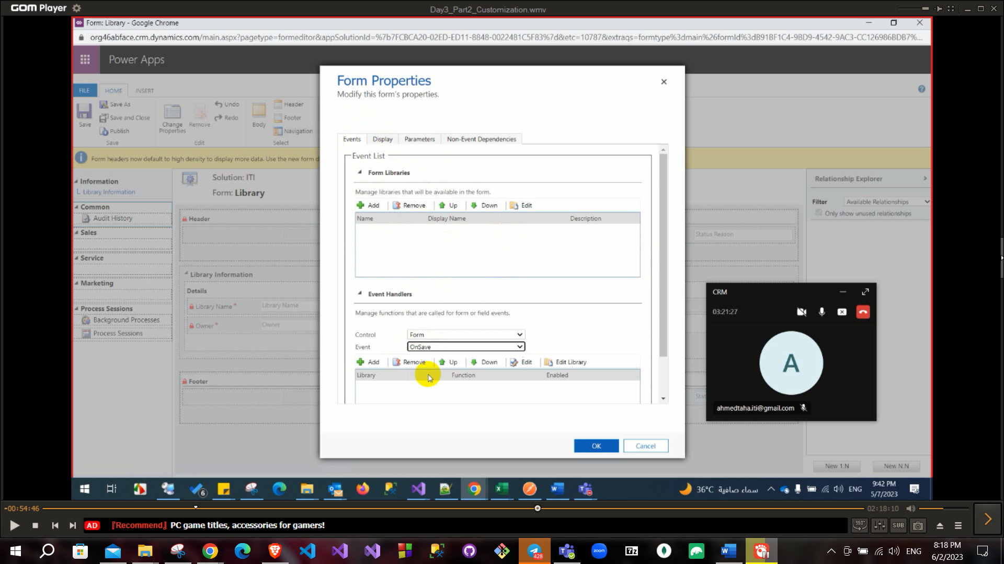

To create a new entity:

Advanced settings – customization – solutions – entity – new

If there is a relationship between created entity and another entity you need to set this relationship according active entity (one to many or many to one).

After creating the entity you can set the relations to other entities

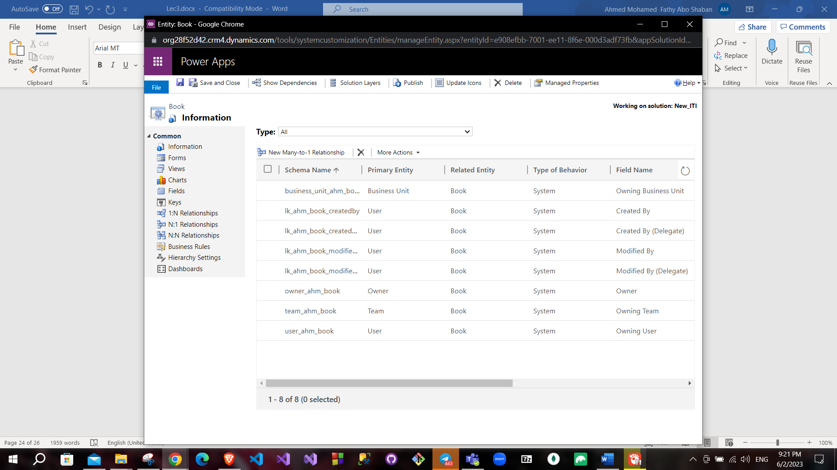

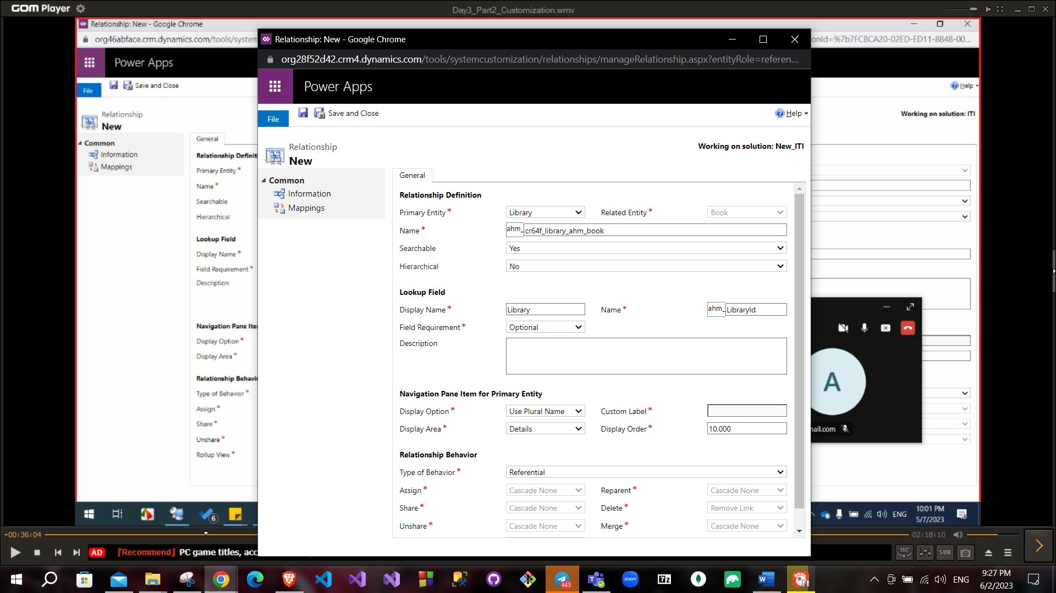

From end of one it has sub-grid also from side of many it has lookup Field requirement has three values:

Business recommended vs business required vs optional. Relationship behavior has four values:

Parental vs referential vs configurable cascading vs Referential, Restrict cascading:

**will discuss later but it very important.

To insert sub-grid to map relationship from insert tab – sub-grid and it will be mapped automatically also you can to apply pagination in sub-grid.

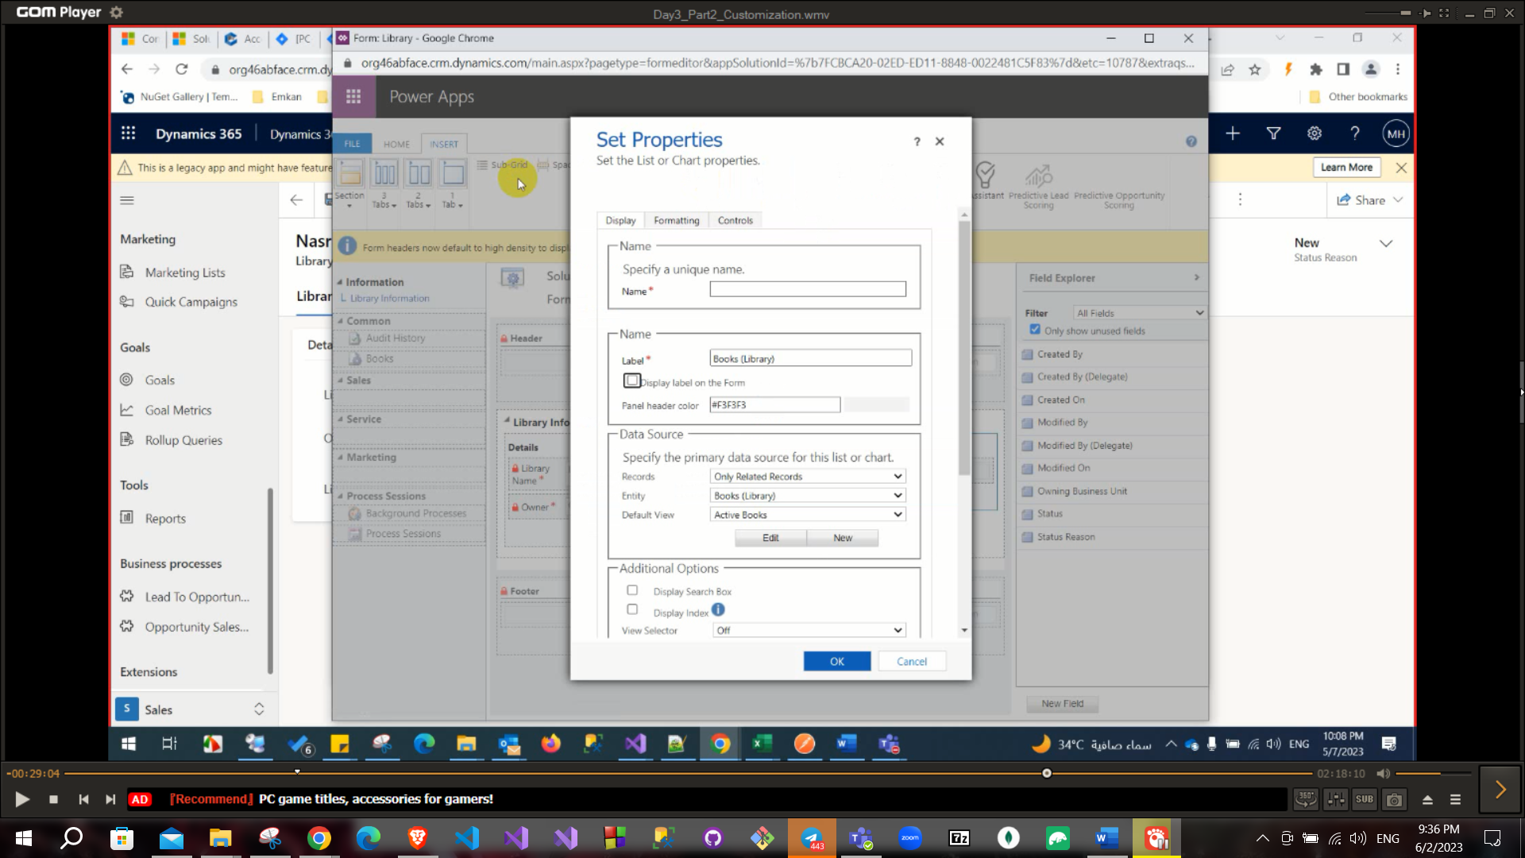

**You can add option set as field and also add option set as a global not related to specific entity (For example to create a shared option set among all entities you need to create from main category not from field).

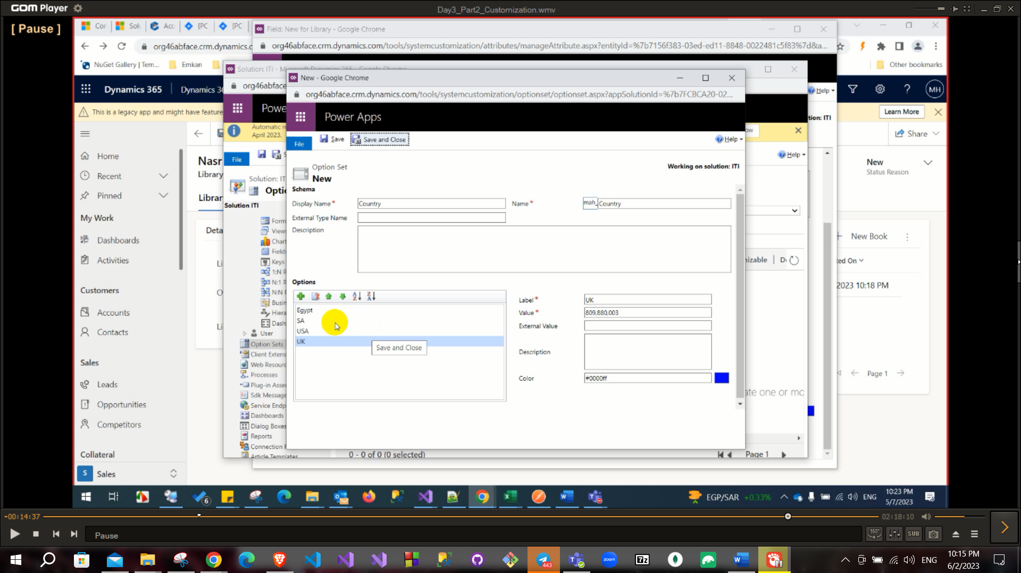

**You can edit your view inside this entity and customize this as you can.

To set a conditional event: you have two choices JS or business rules.

Business rules:

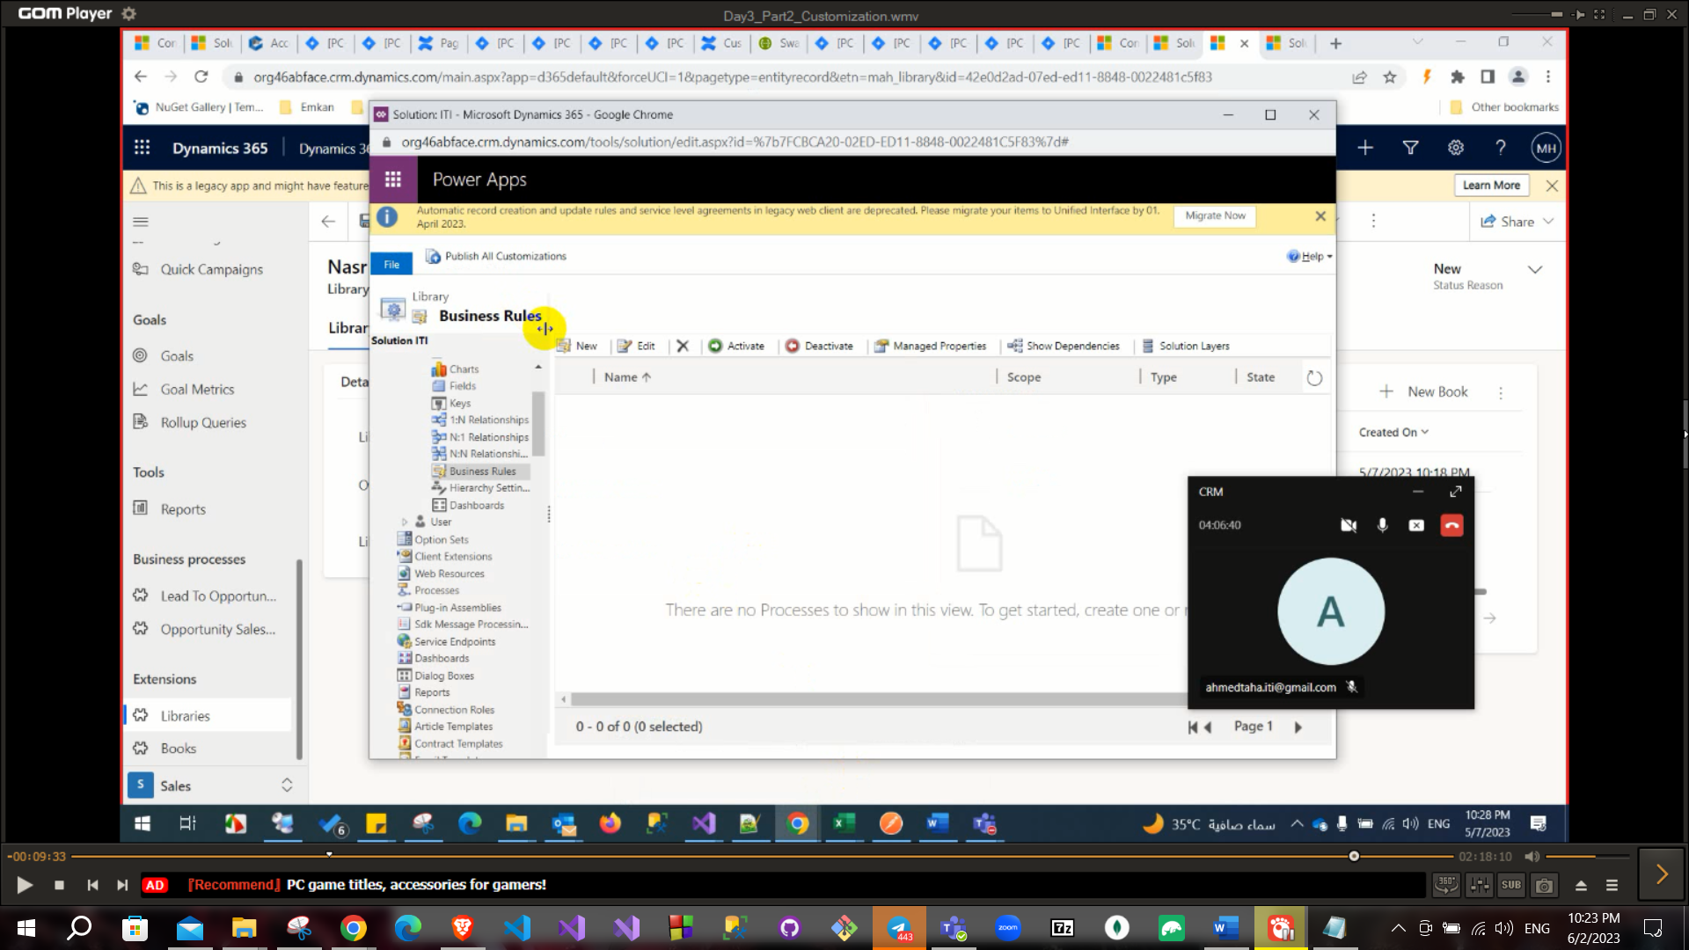

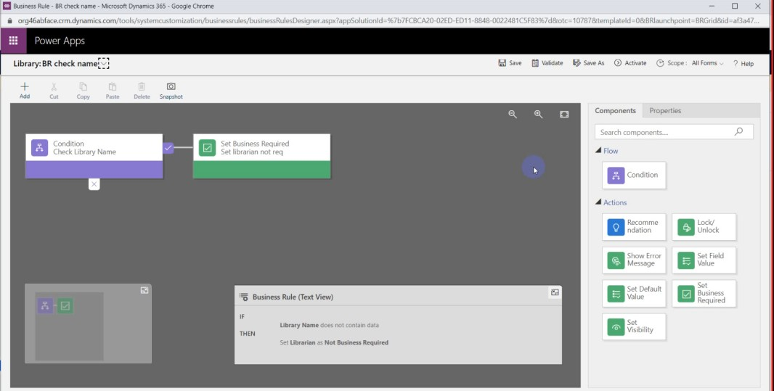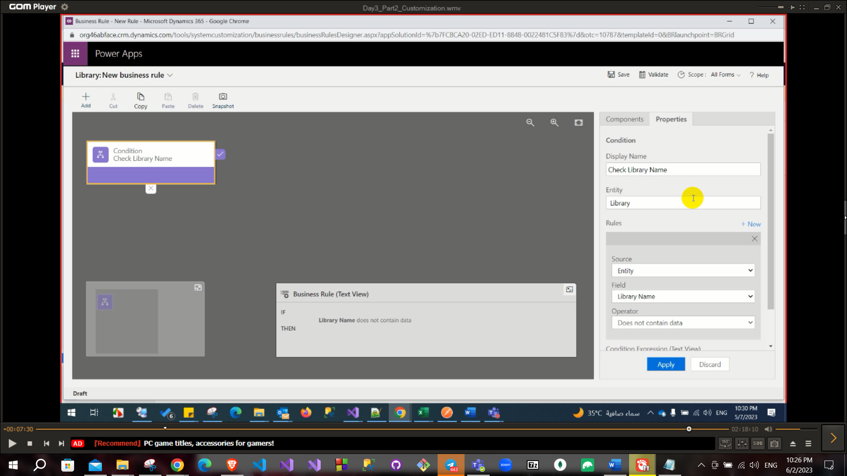

-Some important questions in Customization

SLA, Queue, Field Security, Append, Append to, Levels of security roles, difference between team and access team, inside Product catalog, business role